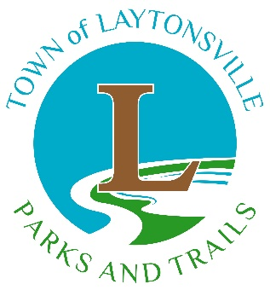

COMMEMORATIVE TREE APPLICATION

The Commemorative Tree Program was established by the Mayor and
Town Council as a way to honor family members and friends.

Please print all information

Name of Applicant: ____________________________________________________________
Address: _____________________________________________________________________
_____________________________________________________________________________
Email: ___________________________________ Phone: ___________________________
Name of Honoree: _____________________________________________________________

Suggested wording for engraving on plaque. Up to three lines. 45 characters, including spaces, per line.
_____________________________________________________________________________
_____________________________________________________________________________
_____________________________________________________________________________
TERMS AND CONDITIONS
- The Laytonsville Parks and Trails Task Force reserves the right to select the species of tree to be planted in the park property. Task Force members will work with the person purchasing the commemorative tree to find a mutually agreed upon location.

- The selection of the tree species will be determined by availability and the design plan for the park.

- The schedule for when to plant a tree is at the discretion of the Mayor. Trees are generally planted in the spring or fall to ensure the successful planting and health of the tree.

- If the Laytonsville Town Council decides that a tree needs to be replaced, when possible, the applicant will be contacted and informed about the replacement.

- No orders will be processed until payment is received. The cost, including the purchase, planting and maintenance of the tree, and the installation of a commemorative plaque, is $1,000.00. Checks are to be made payable to the Town of Laytonsville.

By signing below, the applicant understands and accepts the terms stated herein.

__________________________________________________ _______________________
Signature of Applicant Date

Questions may be directed to:
Laytonsville Parks & Trails Task Force at laytonsvilleparkstrails@gmail.com

Please Return Completed Application and Payment to:
Town of Laytonsville
PO Box 5158
Laytonsville, MD 20882

